C.AAA (Authentication, Authorization, Accounting): Three core functions, AAA in Networking & Security, AAA Deployment Models.
Tasks
1.Create a table comparing Authentication, Authorization, and Accounting (AAA) by listing at least two real-world examples of each function from popular apps like Instagram, Zomato, or Paytm.

AAA Function | Purpose | Real-World Example 1 | Real-World Example 2
Authentication | Verifies the identity of a user before granting access. | Logging into Instagram using a username and password. | Logging into Paytm using a mobile number and OTP.
Authorization | Determines what resources or features a user can access after login. | On Instagram, a user can view and edit only their own profile. | On Zomato, restaurant owners can manage their restaurant listings, while customers can only place orders and write reviews.
Accounting | Records and tracks user activities for monitoring and auditing purposes. | Instagram keeps a record of login history and account activity. | Paytm maintains transaction history, including payments, recharges, and money transfers.

2.Draw a simple network diagram showing how AAA is used to secure access to a WiFi network in a college campus, labeling where authentication, authorization, and accounting take place. Hint: Include devices like user laptops, access points, AAA server, and the internet gateway.
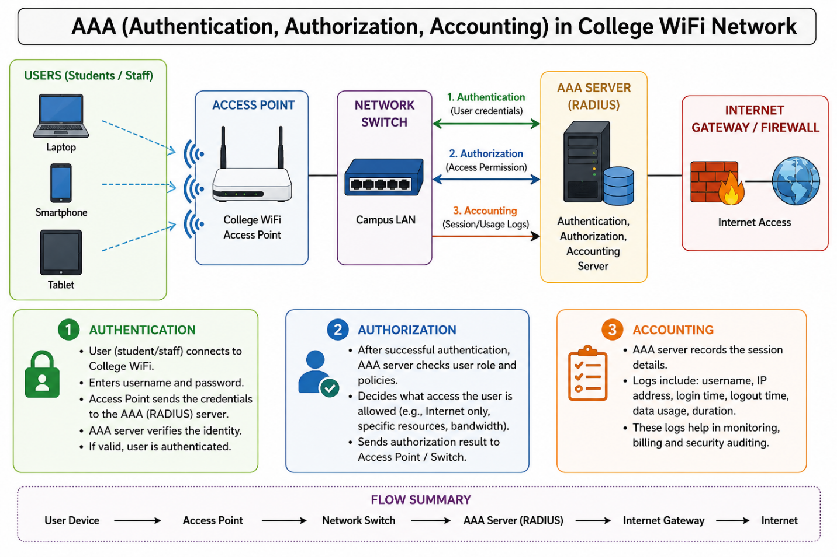
The diagram shows how AAA (Authentication, Authorization, and Accounting) is used to secure a college WiFi network. First, a student or staff member connects to the college WiFi using a laptop, smartphone, or tablet through the Access Point. When the user enters their username and password, the Access Point sends these credentials to the AAA Server (RADIUS) for Authentication, where the server verifies the user's identity. If the login details are correct, the user is allowed to access the network.
After successful authentication, the AAA Server performs Authorization by checking the user's role and permissions. Based on the user's status, such as student or staff, the server decides what resources and services they are allowed to access. For example, students may be allowed to access the internet and online learning portals, while staff members may also access internal college systems and databases.
Finally, the AAA Server performs Accounting by recording the user's network activities. It keeps logs such as login time, logout time, IP address, session duration, and data usage. These records help the college monitor network usage, improve security, and troubleshoot issues when necessary. In this way, AAA ensures that only authorized users can access the college WiFi while maintaining proper security and activity tracking.
3.Explain the difference between centralized and distributed AAA deployment models by describing how each would work in a scenario where multiple Flipkart warehouses need secure network access.

Feature | Centralized AAA Deployment | Distributed AAA Deployment
Definition | A single central AAA server manages authentication, authorization, and accounting for all locations. | Each warehouse has its own local AAA server to manage authentication, authorization, and accounting.
Management | Easier to manage because all policies and user accounts are stored in one place. | More complex because policies and user accounts must be maintained on multiple servers.
Cost | Lower hardware and maintenance costs. | Higher cost due to multiple AAA servers.
Reliability | If the central server or WAN link fails, users may not be able to authenticate. | Warehouses can continue operating even if the connection to headquarters is lost.
Scalability | Easy to add new warehouses by connecting them to the central server. | New warehouses require installation and configuration of local AAA servers.
4.Pick any one AAA deployment model and list three advantages and two disadvantages of using it for a large-scale app like BookMyShow.
Advantages:
- Easy Management – All user accounts, permissions, and security policies are managed from a single server, making administration simple.
- Consistent Security – Every user follows the same authentication and authorization policies, ensuring uniform security across BookMyShow.
- Lower Cost – Only one central AAA infrastructure needs to be maintained, reducing hardware and maintenance expenses.
Disadvantages:
- Single Point of Failure – If the central AAA server fails, users may be unable to log in or access services.
- Network Dependency – Authentication requests depend on connectivity to the central server, so network issues can cause delays or service interruptions.
5.Use ChatGPT or another AI tool to generate a sample AAA policy for a Zomato-like app, specifying what actions are authenticated, which roles are authorized for each action, and what accounting logs should be kept. Paste the generated policy and highlight one thing you would change to make it more secure.
A sample AAA (Authentication, Authorization, and Accounting) policy for a Zomato-like app would require all users, including customers, restaurant owners, delivery partners, and administrators, to authenticate themselves using a mobile number, email, password, or OTP before accessing their accounts. Once authenticated, Authorization determines what each user is allowed to do. Customers can browse restaurants, place orders, make payments, view order history, and submit reviews. Restaurant owners can manage menus, update prices, and accept or reject orders. Delivery partners can view assigned deliveries and update delivery status, while administrators can manage user accounts, monitor platform activity, and generate reports. For Accounting, the system keeps records of important activities such as login and logout times, failed login attempts, password changes, food orders, payment transactions, refunds, delivery updates, menu modifications, administrator actions, and IP addresses used for login. These logs help in monitoring, auditing, troubleshooting, and improving security.
One change I would make to improve security is to enable Multi-Factor Authentication (MFA) for restaurant owners and administrators. This would require an additional verification step, such as an OTP or authenticator app, making it much harder for attackers to gain unauthorized access to high-privilege accounts even if passwords are compromised.

